**DOCUMENTATION FOR TASK PLANNER APPLICATION**

**Name: Kranthi Kumar Reddy Anugu**

**ID:1974268**

**GitHub Repository URL**: **https://github.com/kranthireddy47/1974268_kranthireddy_TCSMEANSTACK.git**

**Note:** I have developed Task Planner Application.

This application contains two files

1. Taskp.js
2. Emp5.json

I have pushed all these files to GITHUB under the commit “**Task Planner Application**”

In this application you can

1. Add your tasks.
2. Delete Task
3. Display all the tasks.

To develop this application I have used three modules

a) File System

b) Hyper Text Transfer Protocol (HTTP)

c) Uniform resource locator

**Links used in the Application:**

1. [**http://localhost:9090**](http://localhost:9090)
2. [**http://localhost:9090/display**](http://localhost:9090/display)

1)When you run the application(taskp.js) you can see

“TASK planner APPLICATION” with some fields to fill in.

* You can add task by entering details.
* You can delete the task by entering Taskid

2)You have to fill the following details which are being displayed.

a) Emp ID

b) Task Id

c) Task

d) Deadline

e) Password

3) When you click on **ADD TASK** the data is inserted into json file.(emp5.json)

4) you can insert as many record as you can with unique tasked. All these data is displayed in the form of a table.  
when you use the following URL

[**http://localhost:9090/display**](http://localhost:9090/display)

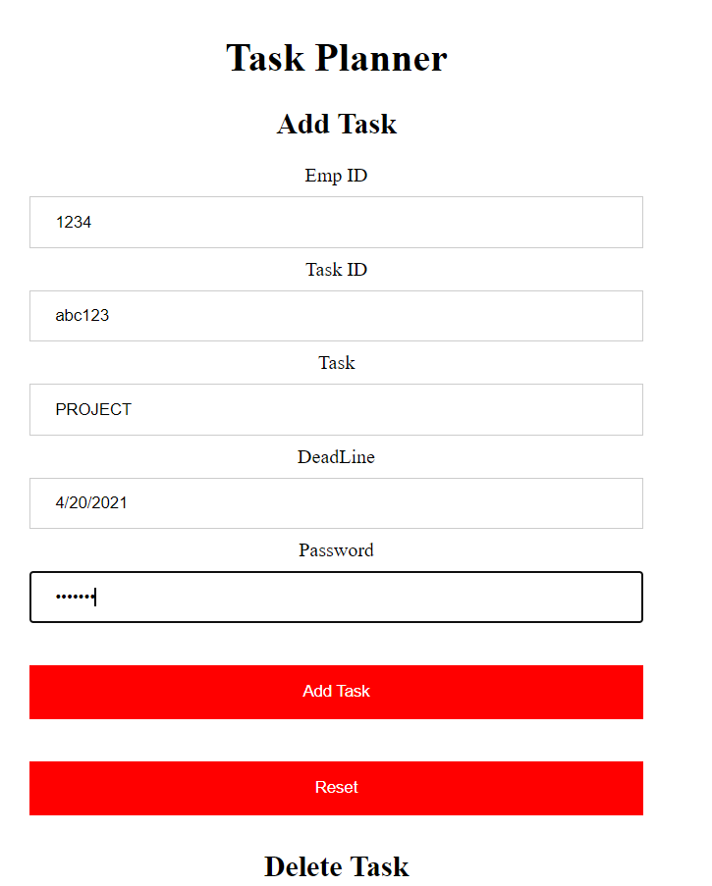

5)You can delete the task by entering the taskId. This task details will be deleted from the emp5.json file. I have iterated through loop to search for the taskid in the json file and used **slice** method to delete it.

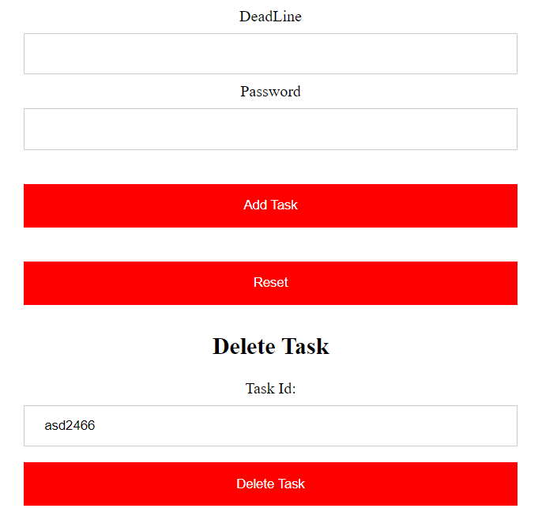

6)When you want display all tasks they will be displayed in a tabular format along with other details which you have entered while adding the task.

* This table is dynamic i.e you cab add as many as tasks and delete them as you complete the task before mentioned deadline.

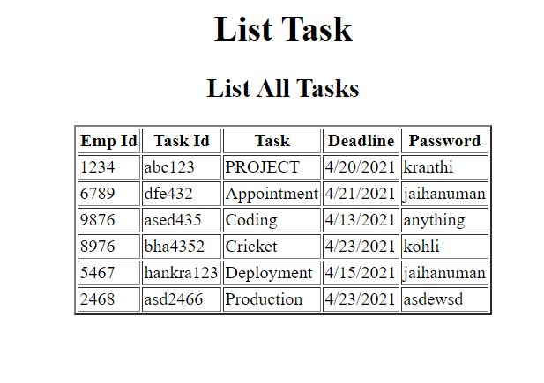

7)I have used file read and file write operations which are included in the File System Module.

The structure of the json file(emp5.json) looks like this

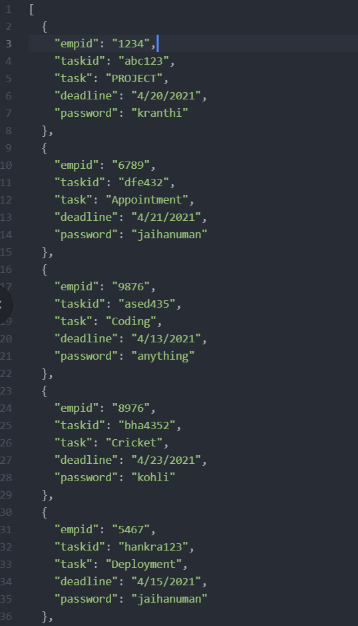

Note: I also created the .ignorefile and ignored the output screenshots and documentation file.

